# 

# big up your book

**A video chat book group for children Wednesdays from 4.00pm to 4.30pm**

Chat with our library hosts and other children about the books you’ve been reading!

Please email [library@plymouth.gov.uk](mailto:library@plymouth.gov.uk) with your child’s name, age and library card number for more information.

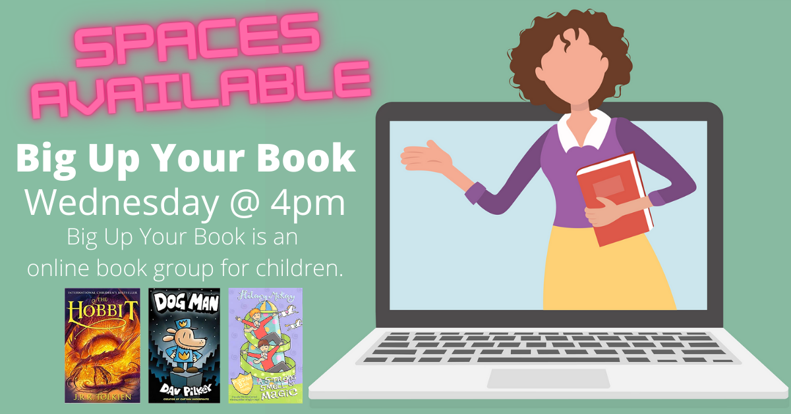

This session will be held using Microsoft Teams.