# TALL TALES

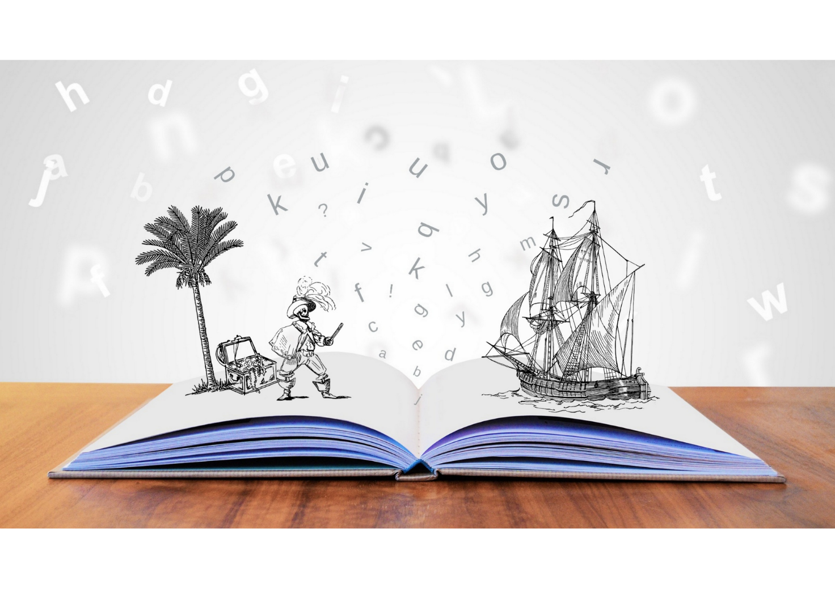

**Central Library**

**Every Thursday at 3.30pm**

Spark your children’s imagination with Tall Tales, our weekly after school storytime sessions for children.

Aimed at children up to age 11 and their families.

**Spaces are limited so booking is required.** Speak to library staff to book your spot.