**Temperate Deciduous Forest**

This biome is defined by its four distinct seasons and its forests of trees that drop their leaves in autumn. (The word “deciduous” [dih-SID-yoo-uhss] comes from a Latin word meaning “to fall.”) Located in the eastern United States, all over Europe, Japan, and parts of Russia and China, temperate deciduous forests are home to deer, wolves, hawks and owls, songbirds, and many other species.

Temperate deciduous forests change dramatically with the seasons.

An entire tourism industry revolves around “leaf peeping.” In the United States, about $30 billion a year is spent by people travelling to see the autumn colours.

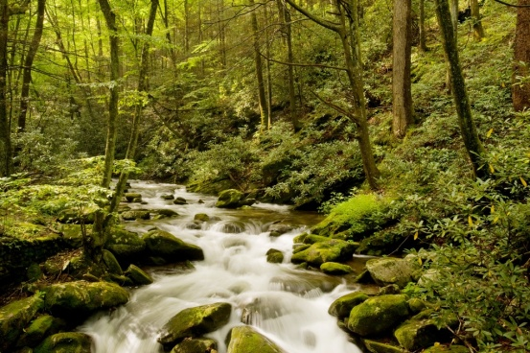Deciduous forests have at least three layers. The tallest trees make up the canopy. Saplings and shrubs are found in the understory. Ferns, moss, and wildflowers grow on the forest floor.

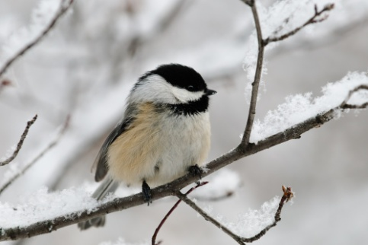Although many birds of the temperate deciduous forest head south for the winter, black-capped chickadees stick around. How do they do it? They hide thousands of seeds under tree bark during the fall and eat them throughout the winter.