**Rainforests**

Located in a belt around the equator, rain forests are a riot of life, with plants growing non-stop year-round. The hot, wet climate supports a jungle of plants and wildlife, from the towering trees that make up the canopy down to the dark forest floor where sunlight barely penetrates due to the thickness of the foliage above. Rain forests get drenched by as much as 180 inches of rain annually.

The rain forest has more species than any other biome. Trees in the rain forest grow as high as 200 feet, and each tree may be home to hundreds of species, from vines and bromeliads, to butterflies, monkeys, birds, and frogs.

Rain forests once covered about 14 percent of the Earth’s land surface, but now account for only about 6 percent. Rain forest habitats continue to be cut down for their wood products and to create land for farming. Every year about 9,000 square miles of rain forest is cut down—that’s an area about the size of New Jersey.

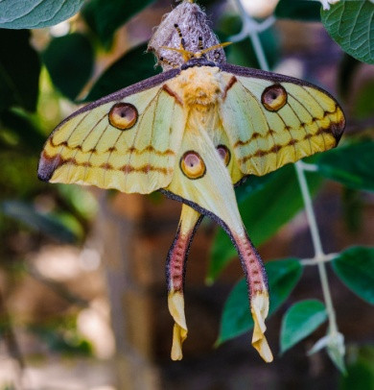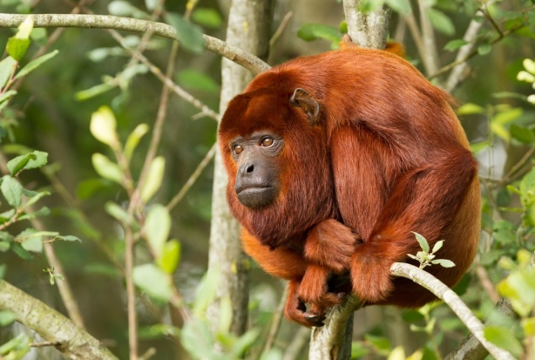Howler monkeys live almost entirely in the rain forest canopy. Leaves are the main part of their diet, so they have everything they need high in the sky. Since it’s hard to see through the greenery in the canopy, animals that live there make a lot of noise to communicate. In fact, howler monkeys are thought to be the loudest animals on land. Their bloodcurdling roars can be heard for three miles.

Plants grow everywhere in the rainforest—even on other plants. This tree trunk in Panama’s rain forest is home to several bromeliads. The mop-top leaves of each bromeliad form a bowl-shape that catches rainwater—and these tiny ponds in the sky are home to insects and even frogs.

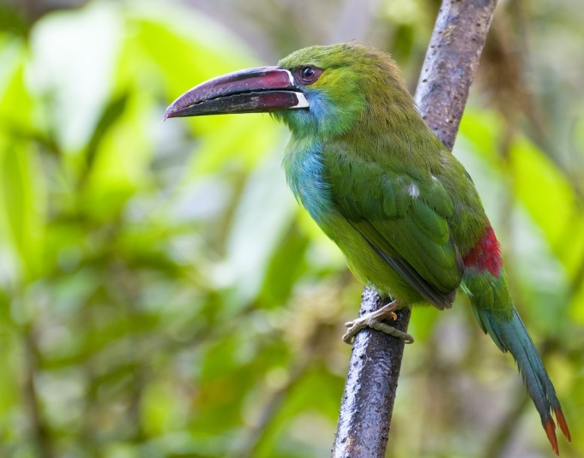Madagascar’s rain forests are filled with astonishing animals, from lemurs and aye-ayes to flying foxes and fossas. This Comet Moth, also called the Madacascan Moon Moth, is one of the largest moths in the world, with a wingspan of eight inches and a six-inch-long tail. It evolved its showy appearance to attract mates. The eyespots mimic the red eyes of lemurs—and are there to confuse predators.

About 40 species of toucans live in rain forests in Central and South America. These big-billed birds nest in tree hollows and eat mostly forest fruits. The crimson-rumped toucanet—pictured here—lives in the mountain rain forests of Ecuador.