**Taiga**

The taiga is the world’s biggest biome. It covers nearly one-fifth of the Earth’s land surface and stretches across northern Canada and northern Eurasia in an almost unbroken belt for 7,000 miles. The main features of the taiga are its evergreen forests of needle-leafed trees, including pine, spruce, hemlock, and fir. Although this biome is not as harsh as the tundra, all its plants and animals have evolved to survive the taiga’s long, snowy winters.

*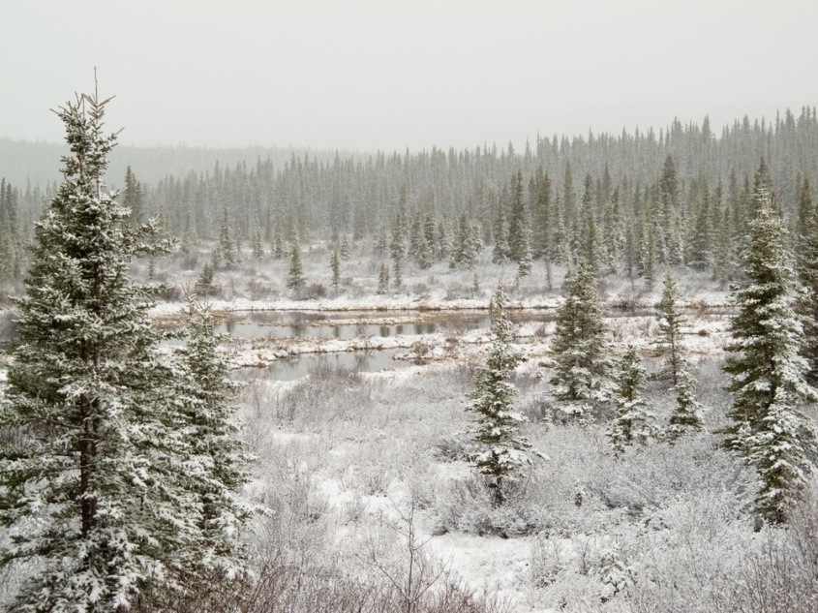Taiga trees have many adaptations for surviving harsh winters, a short growing season, and nutrient-poor soil. Their conical shapes allow snow to slip off easily, without weighing down and breaking branches. Their needle-shaped leaves have waxy, protective coatings to lock in moisture. Plus, the needles don’t all fall off in autumn. Keeping the leaves through the winter means taiga trees don’t need to use energy to grow an entire set of new leaves each spring and they can capture energy from the sun throughout the year.*

*[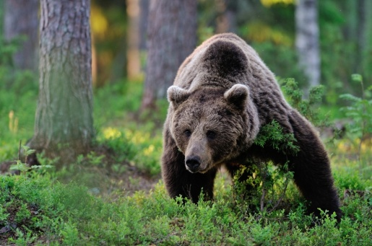](http://cdn4.kidsdiscover.com/wp-content/uploads/2013/10/5.jpg)Brown bears are top predators of the taiga, hunting everything from deer to fish. They also like berries, nuts, roots, and other vegetation. During the summer, they eat massive amounts of food, sometimes as much as 40 pounds per day. Their bodies convert much of this extra food and store it as fat. In autumn, brown bears dig dens and begin long winter hibernations, during which they live off the stored fat.*

*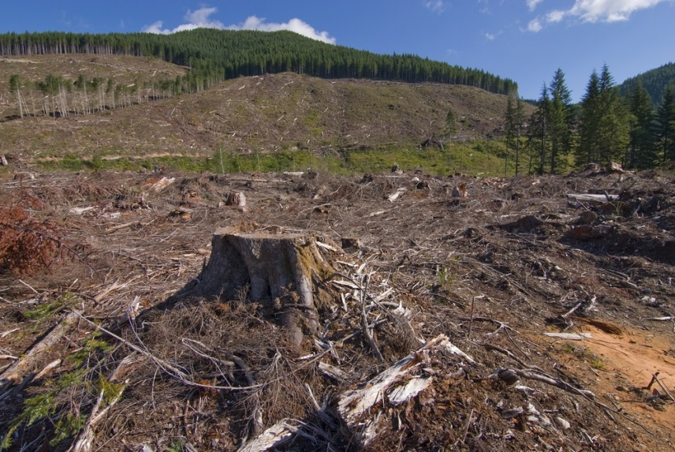The vast forests of the taiga are being shrunk by massive logging operations. The wood is used to make paper and build houses. When trees are clearcut, the forest habitat is destroyed. Reducing the size of the world’s forests also contributes to global warming. Forests are called “carbon sinks” because they absorb carbon dioxide and help keep the world’s carbon cycle in balance. When too much carbon gas is released into the atmosphere, the climate tends to warm—and that can have serious consequences for humans and ecosystems.*