**Tropical Savanna**

Tropical savannas are vast grasslands dotted with trees that spread across Africa, northern Australia, and parts of South America and India. With wide open spaces and so much grass to graze on, savannas are home to large herds of plant-eating animals (herbivores). They are also usually home to large predators that stalk the herds. In the African savanna, the plant-eaters include zebras, antelopes, wildebeest, giraffes, elephants, and rhinos. Predators include lions, leopards, cheetahs, and hyenas. In the Australian savanna, kangaroos are the primary plant-eaters.

Many of Africa’s savanna herbivores have long, powerful legs to help them travel long distances and run away from predators. Some, like the ostrich and giraffe, have VERY long legs—and they can even use them to kick predators. In the Australian savanna, kangaroos have a slightly different strategy for getting around: They don’t run, but hop—as far as 30 feet in a single leap and can speed-hop at 35 mph.

The weather in the savanna is warm year-round, and there are basically two seasons—wet and dry. To survive the dry season, many savanna animals must migrate in search of water.

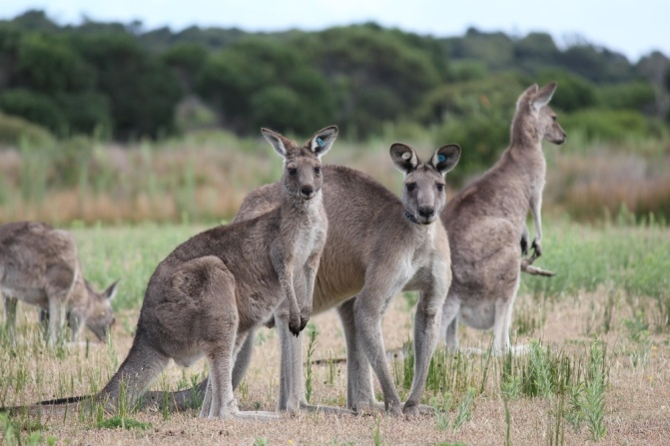These eastern gray kangaroos are just one of over 40 species of kangaroo-like animals, living in Australia’s savannas—better known as “the bush.” Want to know something strange? While kangaroos still have the hair-trigger ability to leap out of danger and escape the sharp teeth of carnivores, most of the kangaroos’ predators have gone extinct.

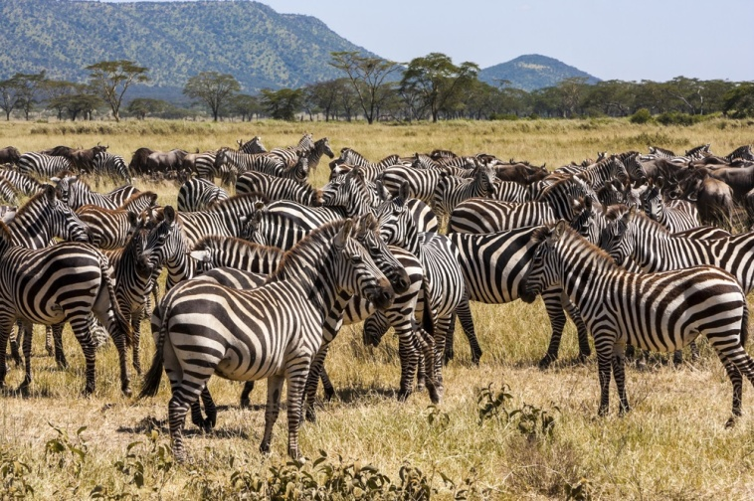

Every year, 300,000 zebra and 1 million wildebeest in Africa’s Serengeti Plain embark on an extended migration. To find water and green grass, they must cross the Mara River. But the crossing is dangerous, with some animals swept away by strong currents and a few attacked by crocodiles.

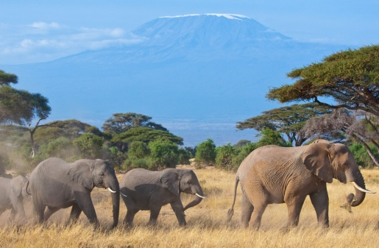

These African elephants are on the move in the savanna beneath Africa’s Mount Kilimanjaro. During the rainy season, elephants get about 50 percent of their diet from grasses. In the dry season, they rely more on trees and shrubs for food.