# 

# LEGO CLUB



**Central Library**

**Every Saturday 2pm to 3.30pm**

Do you have a big imagination and like making things with Lego and Duplo? Come along to our Lego club!

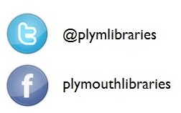Suitable for children over 5yrs accompanied by a parent/guardian.