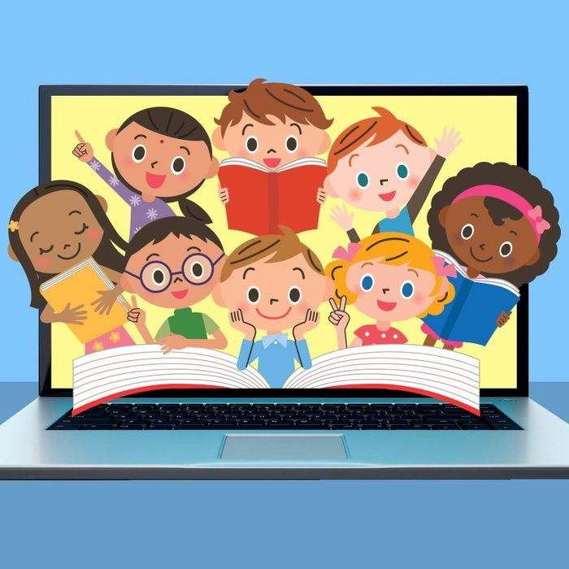
big up your book

Join our book group for children Central Library
Tuesdays 4.00pm to 4.30pm

Chat with library staff and other children about the books you’ve been reading, plus games, quizzes and other activities!
Please ask library staff for more information.

